# ***My Video Player***

**

**Purpose:**

* This class is the entry point of the application.
* It initializes the JavaFX environment and sets up the main stage.

**Methods:**

* `main(String[] args)`: The main method that launches the JavaFX application.
* `start(Stage stage)`: Initializes the stage, loads the FXML file, sets the scene, and defines the close event handler.

**Controller.java**

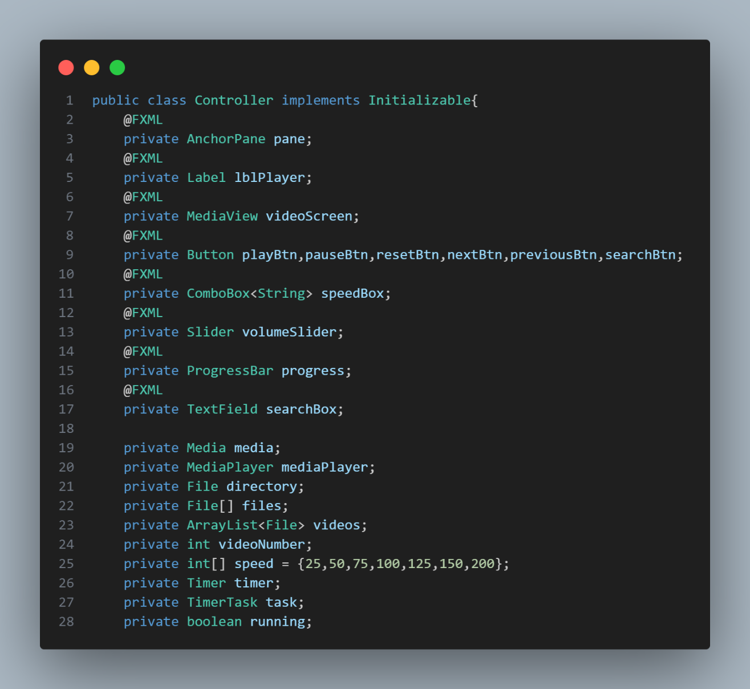**

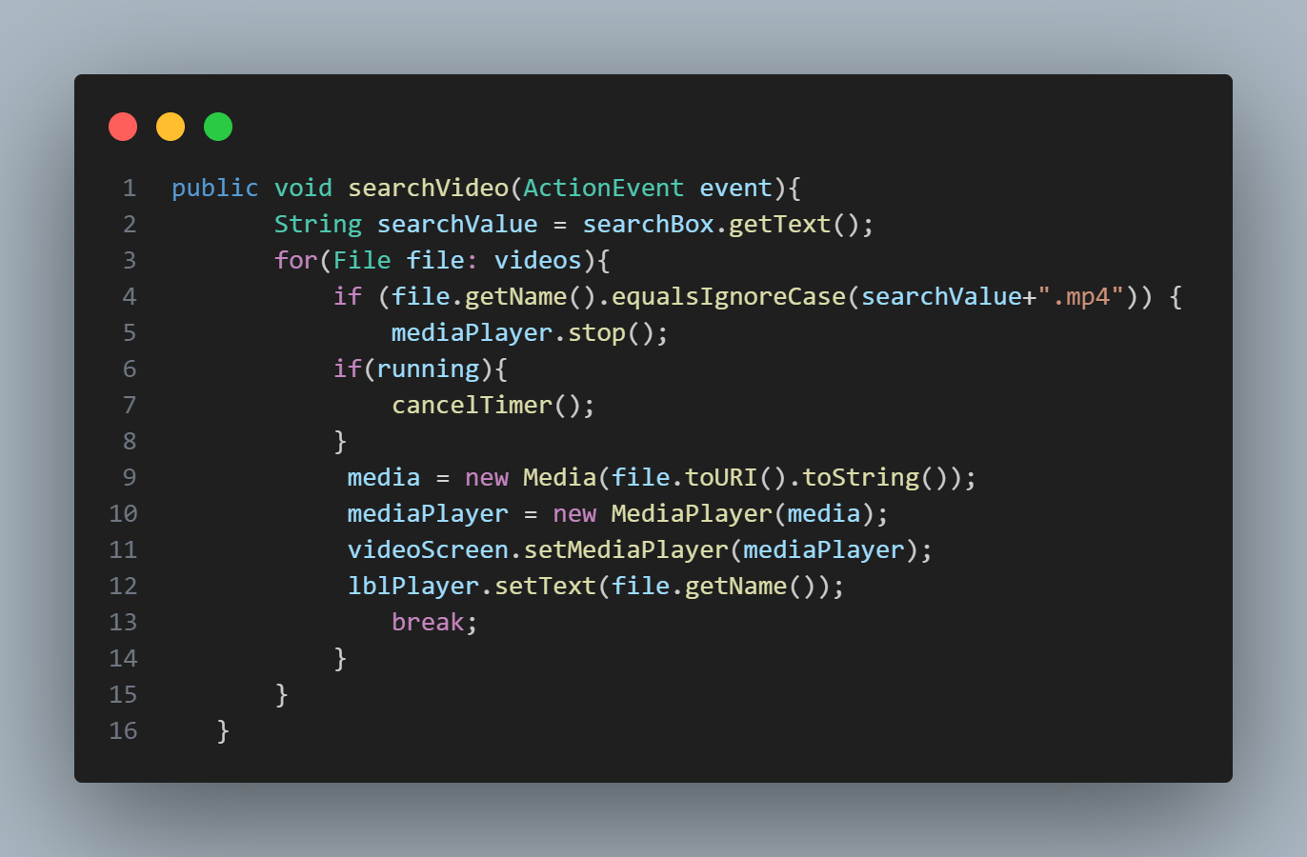

**Purpose:**

* This class serves as the controller for the JavaFX UI defined in the FXML file.
* It handles user interactions and controls the video player.

**Fields:**

* `pane`: AnchorPane for holding UI elements.
* `lblPlayer`: Label to display the current video name.
* `videoScreen`: MediaView for displaying the video.
* `playBtn`, `pauseBtn`, `resetBtn`, `nextBtn`, `previousBtn`, `searchBtn`: Buttons for controlling playback and searching
* `speedBox`: ComboBox for selecting playback speed.
* `volumeSlider`: Slider for adjusting volume.
* `progress`: ProgressBar for displaying video progress.
* `searchBox`: To search video from the imported list of videos.

**Methods:**

* `initialize(URL arg0, ResourceBundle arg1)`: Initializes the controller.
* `playMedia()`, `pauseMedia()`, `resetMedia()`: Control methods for playback.
* `previousVideo()`, `nextVideo()`: Methods for navigating to the previous or next video.
* `searchVideo(ActionEvent event)`: Searches for a video based on the entered query.
* `searchVideo`
* `changeSpeed(ActionEvent event)`: Changes the playback speed.
* `beginTimer()`, `cancelTimer()`: Methods for managing the progress update timer.

**Fields:**

* `media`, `mediaPlayer`: Instances for handling media and media playback.
* `directory`, `files`, `videos`: Variables related to video files and directory.
* `videoNumber`: Index of the currently playing video.
* `speed`: Array containing playback speed options.
* `timer`, `task`: Timer and TimerTask for updating video progress.
* `running`: Flag to indicate whether the timer is running.

**FXML FILE :**

The FXML file represents the layout of a video player interface using JavaFX. It consists of an AnchorPane containing several UI components. There are buttons for play, pause, reset, next, and previous actions. A slider is provided for adjusting the volume, and a combo box is used for selecting playback speed. A progress bar indicates the current playback progress. The video itself is displayed within a MediaView element. Additionally, there's a label at the bottom displaying the name of the video being played. The interface is styled with a black background and blue text. Overall, it's a simple and user-friendly interface for controlling video playback.

**CONCLUSION**

The `App` class is responsible for starting the application and setting up the main stage, while the `Controller` class manages the UI elements and controls the video player functionality. Together, they create a simple video player application using JavaFX.

**OUTPUT VIDEO LINK:**

<https://drive.google.com/file/d/1wx5xB7-2TtlAn03ImJcuwylJ7Lk1T1h-/view?usp=drive_link>